Student Performance Prediction System

Project Id: AIML-18

Name : Pawani Gupta (Team Leader)
Class Roll Number:13
University Roll Number : 2028463
Section and Group: P G1

Name : Riya Gupta
Class Roll Number:13
University Roll Number : 2028477
Section and Group: P G1

Name : Tamanna Bhinder
Class Roll Number:24
University Roll Number : 2028507
Section and Group: P G1

TABLE OF CONTENTS
- Problem Description 3
  - Dataset Description 3
  - Flow diagram 4
- Modules for Project Implementation…………………..…………………………5
  - Modules Used 5
  - Platform Used 6
- Machine Learning model/ Searching Technique used 7
- Evaluation metrics used 8
- Results and Visualizations 9
- Conclusion and Future Scope 11
- References 12

- Problem Description
Heart disease remains one of the leading causes of mortality worldwide, making early detection and prevention critically important. Traditional diagnosis methods often require extensive medical testing, which can be time-consuming, costly, and not always accessible in all regions. Therefore, there is a need for an efficient, data-driven approach to identify individuals at risk of heart disease using readily available clinical and lifestyle parameters.
This project aims to develop a Heart Disease Prediction System using machine learning techniques. The system analyzes patient data such as age, blood pressure (BP), cholesterol level, body mass index (BMI), lifestyle habits (smoking, alcohol consumption, physical activity), stress levels, sleep patterns, and medical history (diabetes, hypertension, family history). By leveraging these features, the model predicts whether a person is at high risk or low risk of developing heart disease.
The core objective is to:
- Build a predictive model that can classify individuals based on their risk level.
- Apply data preprocessing techniques such as handling missing values, encoding categorical variables, scaling features, and managing outliers.
- Train multiple machine learning models and evaluate their performance using metrics like accuracy, precision, recall, and F1-score.
- Identify the most effective model for accurate and reliable prediction.
This system can assist healthcare professionals in early diagnosis and also serve as a preventive tool for individuals by providing insights into their cardiovascular health risk based on lifestyle and medical attributes.

1.1 Dataset Description
The dataset used in this project consists of patient health records and lifestyle-related attributes that are relevant for assessing the risk of heart disease. It includes both numerical and categorical features, providing a comprehensive view of an individual’s medical condition and daily habits.
Each row in the dataset represents a unique individual, while each column corresponds to a specific feature influencing cardiovascular health.
Features in the Dataset
- AGE: Represents the age of the individual. Age is a significant risk factor, as the probability of heart disease increases with advancing age.
- BP (Blood Pressure): Indicates the blood pressure level of the individual. High blood pressure (hypertension) is a major contributor to cardiovascular diseases.
- CHOLESTROL: Represents the cholesterol level in the blood. Elevated cholesterol can lead to plaque buildup in arteries, increasing heart disease risk.
- gender: A categorical feature indicating the gender of the individual (e.g., Male/Female). Gender can influence susceptibility to heart conditions.
- bmi (Body Mass Index): Measures body fat based on height and weight. Higher BMI values are often associated with obesity, which is a known risk factor.
- family_history: Indicates whether there is a history of heart disease in the family (Yes/No). Genetic predisposition plays an important role in cardiovascular risk.
- smoking_status: Represents whether the individual is a smoker or non-smoker. Smoking significantly increases the risk of heart disease.
- alcohol_consumption: Describes the level of alcohol intake (e.g., Low, Moderate, High). Excessive alcohol consumption can negatively impact heart health.
- physical_activity: Indicates the level of physical activity (e.g., Low, Moderate, High). Regular exercise reduces the risk of heart disease.
- stress_level: Represents the individual’s stress level (e.g., Low, Moderate, High). Chronic stress can contribute to heart-related problems.
- sleep_hours: Indicates the number of hours the individual sleeps per day. Poor sleep patterns are associated with increased cardiovascular risk.
- diabetes: A binary feature (0/1) indicating whether the individual has diabetes. Diabetes is closely linked with heart disease.
- hypertension (Target Variable): A binary feature (0/1) indicating the presence of high blood pressure. In this project, it is used as a proxy indicator for heart disease risk classification.

Dataset Characteristics
- The dataset contains both numerical and categorical variables, requiring preprocessing techniques such as encoding and scaling.
- It includes medical, behavioral, and lifestyle factors, making it suitable for predictive modeling.
- The target variable is binary, making this a classification problem.

1.2 Flow Diagram
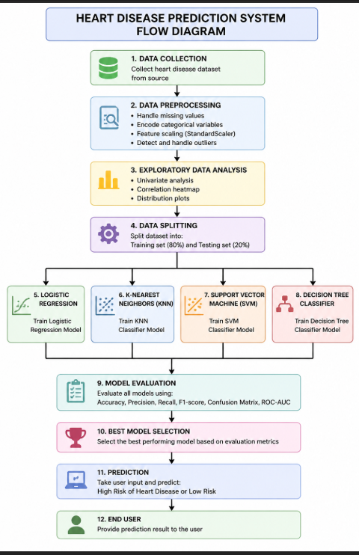

2. Modules for Project Implementation

2.1 Modules Used(mention all the inbuilt/ custom modules used and the purpose)

The implementation of the Heart Disease Prediction System utilizes several inbuilt Python libraries and modules for data processing, visualization, and machine learning. Each module plays a specific role in the development pipeline.
1. Pandas
- Purpose: Data manipulation and analysis
- Used for loading the dataset, handling missing values, filtering data, and performing operations on rows and columns.
- Provides DataFrame structures for efficient data handling.

2. NumPy
- Purpose: Numerical computations
- Used for handling arrays, mathematical operations, and reshaping input data for model prediction.
- Ensures efficient computation with large datasets.

3. Matplotlib
- Purpose: Data visualization
- Used to create plots such as pie charts, histograms, and model comparison graphs.
- Helps in understanding data distribution and model performance.

4. Seaborn
- Purpose: Advanced data visualization
- Used for creating heatmaps and statistical plots.
- Particularly useful for correlation analysis between features.

5. Scikit-learn (sklearn)
A machine learning library used for model building, preprocessing, and evaluation.
a) Preprocessing Module
- StandardScaler
  - Used to normalize feature values so that all features are on the same scale.
b) Model Selection Module
- train_test_split
  - Used to divide the dataset into training and testing sets.
c) Machine Learning Algorithms
- LogisticRegression
  - Used for binary classification of heart disease risk.
- KNeighborsClassifier (KNN)
  - Classifies data based on similarity (distance between data points).
- SVC (Support Vector Classifier)
  - Used to create optimal decision boundaries for classification.
- DecisionTreeClassifier
  - Builds a tree-like model for decision making and classification.
d) Evaluation Metrics
- accuracy_score
- precision_score
- recall_score
- f1_score
- confusion_matrix
These metrics are used to evaluate and compare the performance of different models.

6. Custom Functions
The following custom-defined functions were implemented:
- get_user_input()
  - Collects input data from the user via console.
- predict_heart_disease()
  - Processes user input, applies encoding and scaling, and predicts the risk level using the trained model.

2.2 Platform Used: (mention all the platforms with the reason of using it)
  - Visual Studio Code: For code writing, testing, and debugging.
VS Code is equipped with multiple extensions, debugger which enhance the development experience.

3. Machine Learning Model/ Searching Technique Used(Describe each ML model/ searching technique used)

In this project, multiple machine learning classification algorithms were implemented to predict the risk of heart disease. Each model was trained on the preprocessed dataset and evaluated using performance metrics such as accuracy, precision, recall, and F1-score. The best-performing model was selected based on these evaluation results.

3.1 Logistic Regression
Logistic Regression is a supervised learning algorithm used for binary classification problems. It predicts the probability of a data point belonging to a particular class using a logistic (sigmoid) function.
In this project, Logistic Regression is used to classify whether a person is at high risk or low risk of heart disease. It works well when the relationship between features and the target variable is approximately linear.
Advantages:
- Simple and efficient
- Works well for binary classification
- Provides probability-based outputs

3.2 K-Nearest Neighbors (KNN)
K-Nearest Neighbors is a non-parametric, instance-based learning algorithm. It classifies a data point based on the majority class among its nearest neighbors in the feature space.
In this system, KNN uses distance metrics (such as Euclidean distance) to determine similarity between data points. The value of K determines how many neighbors are considered during classification.
Advantages:
- Easy to understand and implement
- No training phase (lazy learning)
- Effective for smaller datasets
Limitations:
- Computationally expensive for large datasets
- Sensitive to feature scaling

3.3 Support Vector Machine (SVM)
Support Vector Machine is a powerful supervised learning algorithm used for classification tasks. It works by finding the optimal hyperplane that separates data points of different classes with the maximum margin.
In this project, SVM helps in handling complex relationships between features by creating clear decision boundaries.
Advantages:
- Effective in high-dimensional spaces
- Works well with clear margin of separation
- Robust to overfitting in many cases

3.4 Decision Tree Classifier
Decision Tree is a supervised learning algorithm that splits data into branches based on feature conditions. It forms a tree-like structure where each internal node represents a decision, and each leaf node represents a class label.
In this project, the Decision Tree model helps in understanding feature importance and provides an interpretable model.
Advantages:
- Easy to interpret and visualize
- Handles both numerical and categorical data
- No need for feature scaling
Limitations:
- Prone to overfitting if not controlled

Model Selection
All four models were trained and evaluated using standard performance metrics. The model with the highest accuracy and balanced precision-recall performance was selected as the final model for prediction.
4. Evaluation metrics used (Describe each evaluation metric used along with formulae)
To evaluate the performance of the machine learning models, several standard classification metrics were used. These metrics help in understanding how well the model predicts the target variable and whether it performs reliably across different classes.
The evaluation is based on the confusion matrix, which consists of:
- True Positive (TP): Correctly predicted positive cases
- True Negative (TN): Correctly predicted negative cases
- False Positive (FP): Incorrectly predicted positive cases
- False Negative (FN): Incorrectly predicted negative cases

4.1 Accuracy
Accuracy measures the overall correctness of the model. It represents the proportion of correctly predicted observations out of the total observations.
$$Accuracy=\frac{TP+TN}{TP+TN+FP+FN}$$
Interpretation:
Higher accuracy indicates better model performance, but it may be misleading if the dataset is imbalanced.

4.2 Precision
Precision measures the accuracy of positive predictions. It indicates how many of the predicted positive cases are actually correct.
$$Precision=\frac{TP}{TP+FP}$$
Interpretation:
High precision means fewer false positives.

4.3 Recall (Sensitivity)
Recall measures the ability of the model to identify all actual positive cases.
$$Recall=\frac{TP}{TP+FN}$$

Interpretation:
High recall means fewer false negatives, which is very important in medical diagnosis.

4.4 F1-Score
F1-score is the harmonic mean of precision and recall. It provides a balance between both metrics.
$$F1=2×\frac{Precision×Recall}{Precision+Recall}$$
Interpretation:
A high F1-score indicates a good balance between precision and recall.

4.5 Confusion Matrix
A confusion matrix is a table used to visualize the performance of a classification model. It shows the number of correct and incorrect predictions made by the model.
 | Predicted Positive | Predicted Negative
Actual Positive | TP | FN
Actual Negative | FP | TN
Interpretation:
It provides detailed insight into model performance beyond accuracy.

5. Results and Visualizations
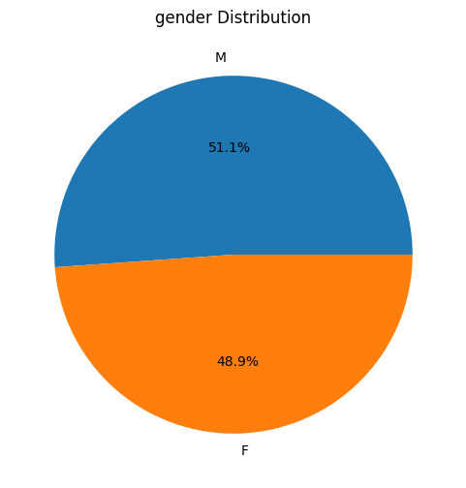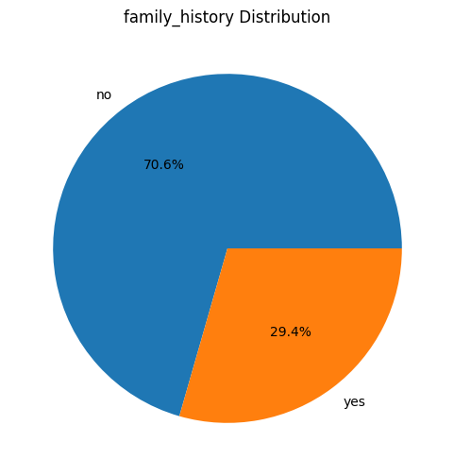

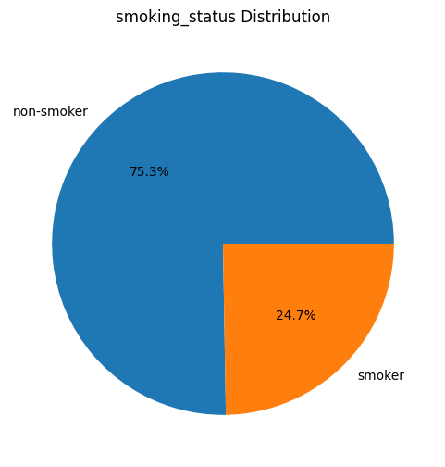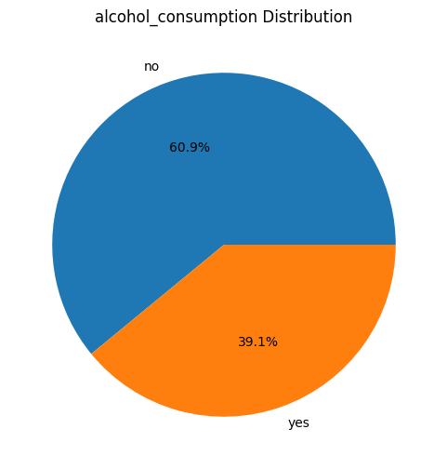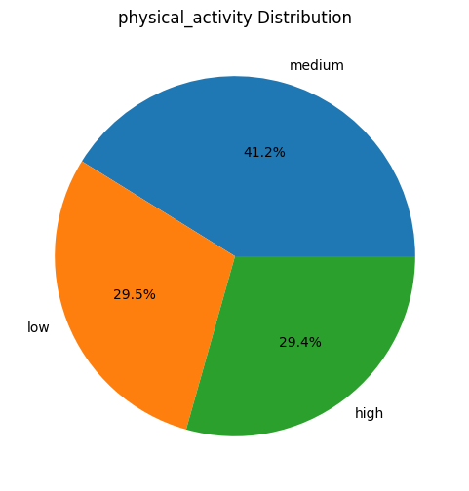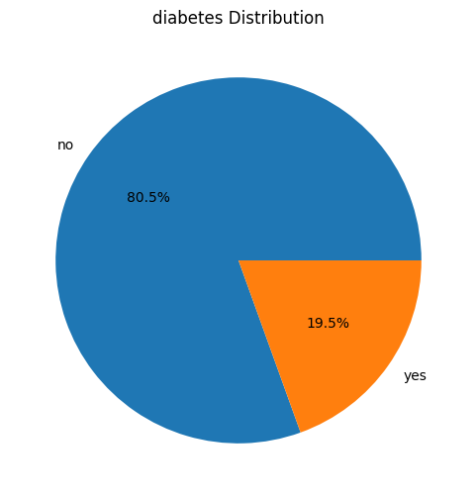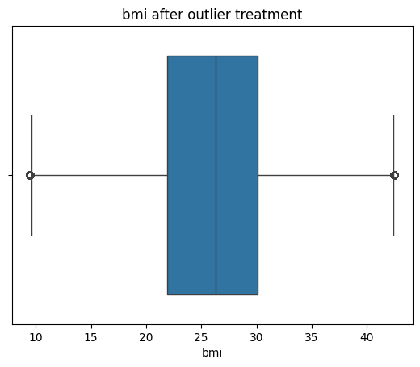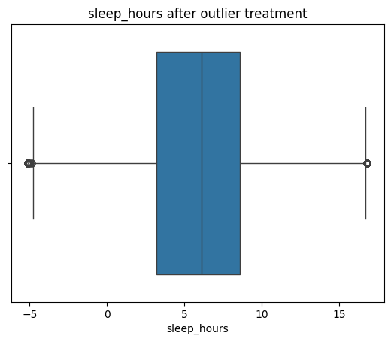
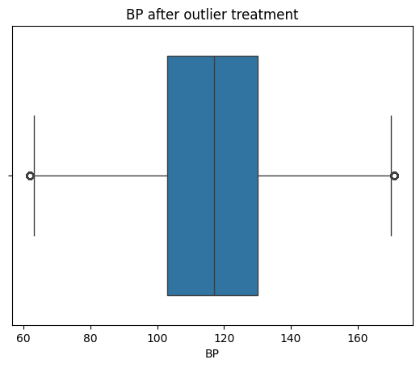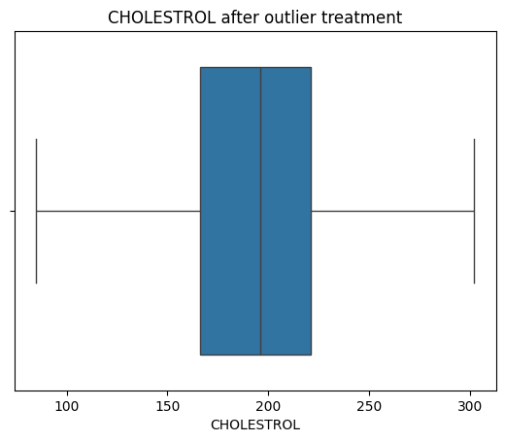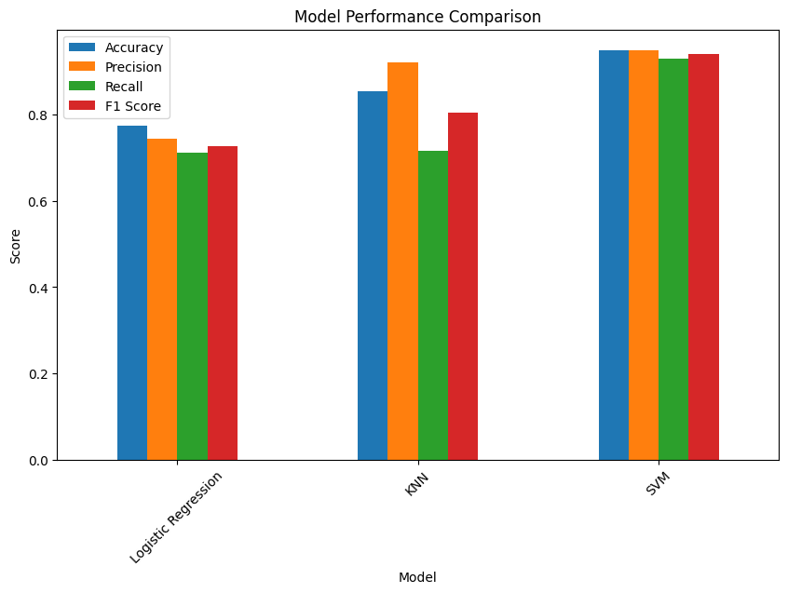
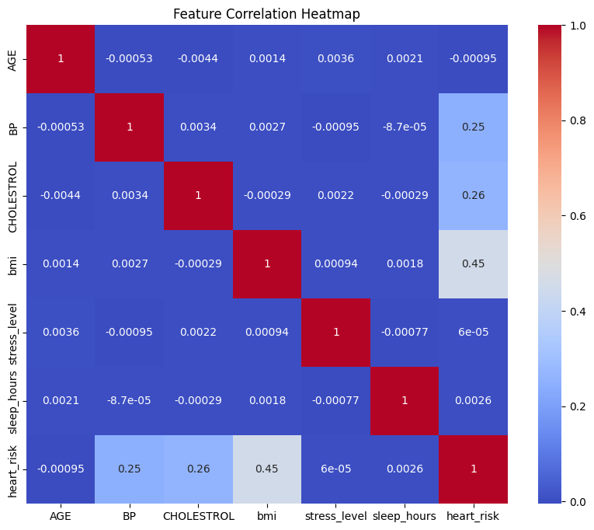
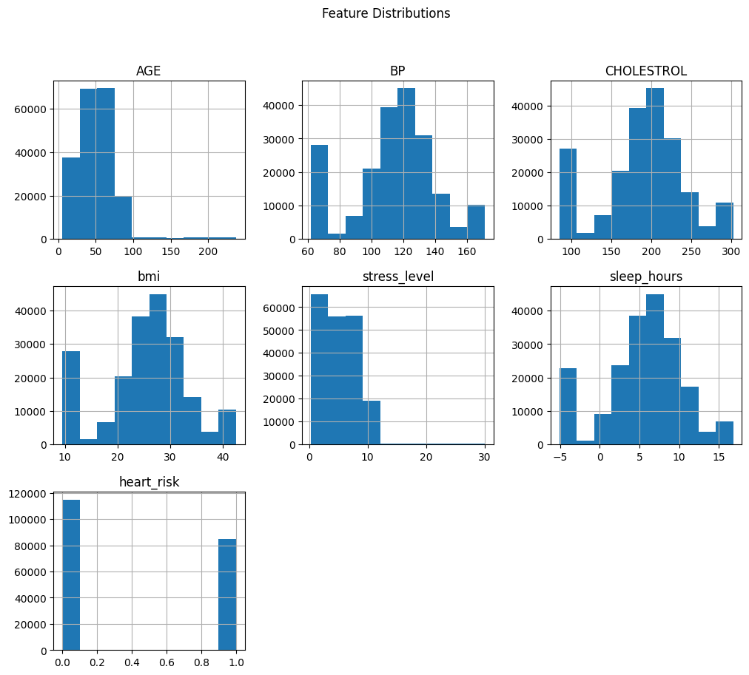
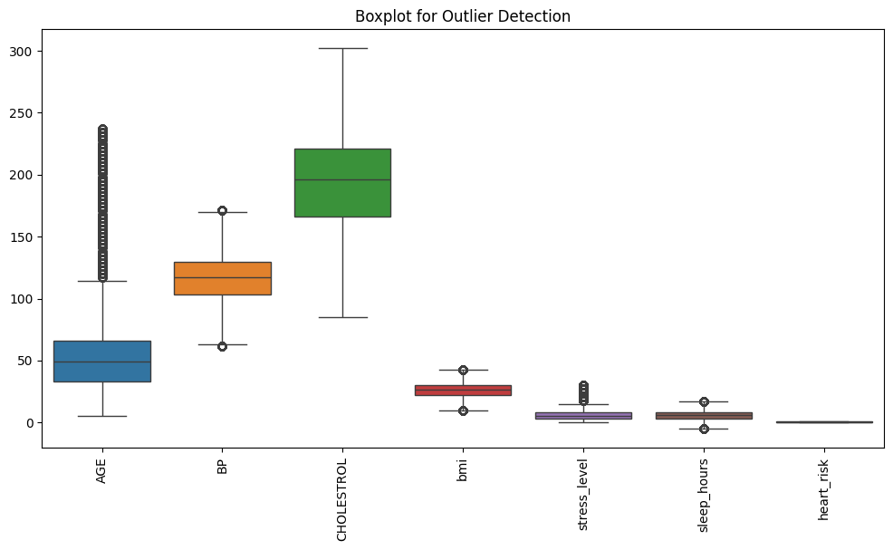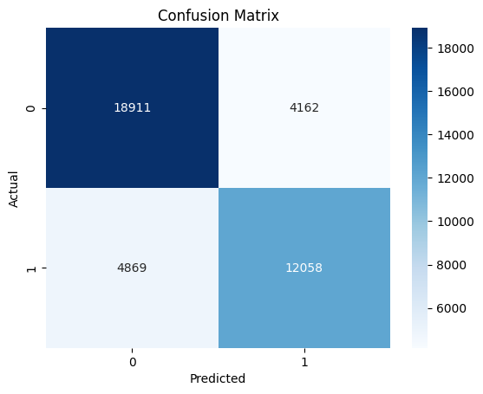
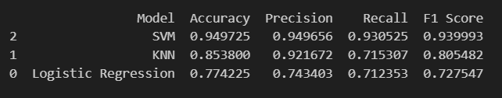
6. Conclusion and Future Scope:
In this project, a Heart Disease Prediction System was successfully developed using machine learning techniques. The system utilizes patient data, including clinical parameters and lifestyle factors, to predict the risk of heart disease.
The dataset was preprocessed by handling missing values, encoding categorical variables, scaling numerical features, and managing outliers. Multiple classification models—Logistic Regression, K-Nearest Neighbors (KNN), Support Vector Machine (SVM), and Decision Tree—were trained and evaluated using performance metrics such as accuracy, precision, recall, and F1-score.
Among the implemented models, the best-performing model was selected based on its overall performance and balance between precision and recall. The final system is capable of taking user input and providing real-time predictions indicating whether a person is at high or low risk of heart disease.
This project demonstrates how machine learning can be effectively applied in the healthcare domain to assist in early detection and preventive analysis, ultimately helping in reducing the risk of severe cardiovascular conditions.

Future Scope
Although the current system performs effectively, there are several areas where it can be further improved and extended:
- Use of Larger and Real-world Datasets
Incorporating more diverse and real-time medical datasets can improve the accuracy and generalizability of the model.
- Integration with Advanced Models
Advanced algorithms such as Random Forest, Gradient Boosting, or Deep Learning models can be used to enhance prediction performance.
- Development of a Web or Mobile Application
The system can be deployed as a user-friendly application using frameworks like Streamlit or Flask, making it accessible to a wider audience.
- Inclusion of More Medical Parameters
Adding features such as ECG results, heart rate variability, and other clinical test data can improve prediction reliability.
- Real-time Monitoring System
Integration with wearable devices (e.g., smartwatches) can allow continuous monitoring and real-time risk assessment.
- Explainable AI (XAI)
Implementing techniques to explain model decisions can help doctors and users understand the reasoning behind predictions.

7. References:
Books:
- Let Us Python – Yashavant Kanetkar

Online Resources:
  - GeeksforGeeks – https://www.geeksforgeeks.org/
  - TutorialsPoint – https://www.tutorialspoint.com/cprogramming/index.htm
  - Stack Overflow – https://stackoverflow.com

